**Date: 14 July 2018**

**Status Updates:**

1. Chantalle will get the personnas and scenarios by Sunday, and subsequently start working on the content for Monsoon website. Things to get for website content:
   1. Chantalle to remind Marvin to provide legal disclaimer for information collection
2. Wordpress Plugins, with a to d being higher priority for now. The rest after acceptance.
   1. Woocommerce (E-store), assigned to Josh
   2. Tawk Livechat, assigned to Jacky
   3. Appointment booking (Need to be in sync with stylists’ scheduling), assigned to wx
   4. Dashboard for salon (Eg. Sales, peak hour, etc. Need to find plugin, if have then need to test), assigned to Josh, Wx, Jacky
   5. Notifications (email and sms, get monsoon to create customer sample emails), assigned to wx
   6. Media (populate pages and pics), assigned to Josh
   7. Translation (need to check), assigned to Jacky
   8. Google Analytics (while dashboard is more for salon, this is more analytics over the website)
   9. Search Engine Optimisation
3. Set up Supervisor meeting with Thivya KANDAPPU, Kis to email her asking her availability but inform her we are on internship
4. Updates to timeline due to Wordpress migration (also update this in Change Management):

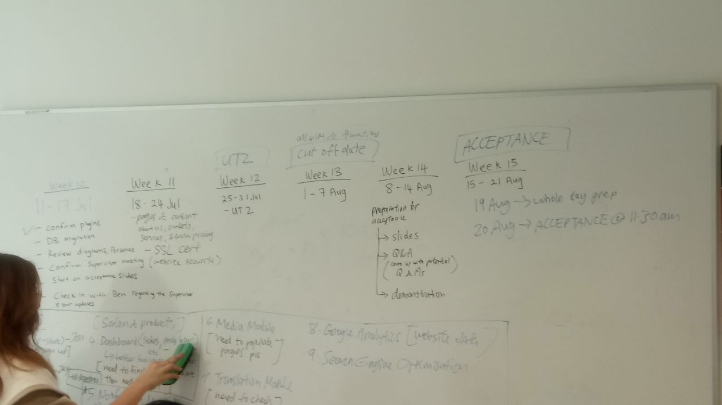

1. Presentation/Acceptance:
   1. Some internal pointers on what to include for presentation
2. Business process diagram:
   1. Consider including assistants in this diagram. 2 assistants for the whole salon, but not tied to any stylist. Might be difficult to map this out so KIV first
   2. Refer to image for diagram